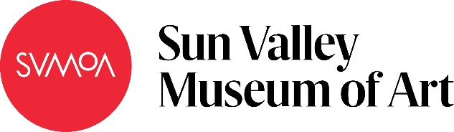

Express Yourself!
Subject: Math
Grade Level: 6
Lesson Plan: Five 50-minute classes

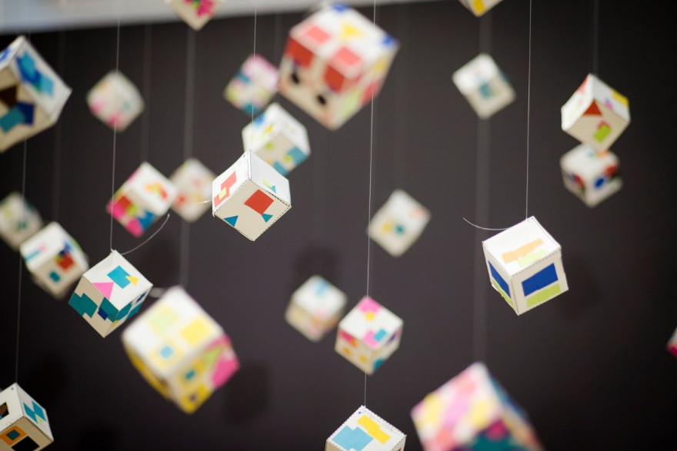

Students explore how to decompose and recompose equations and how equivalent expressions can be expressed differently. This graphic design project uses symbols to create various expressions of the same equation on each side of a cube. Symbols represent numerical values, giving students a key from which to base their designs and equations.

Objectives:
- Students will learn to plan compositions
- Students will develop patterns using symbols
- Students will consider movement, balance, and color in their sculptures
- Students use equivalent expressions to design different patterns on each side of their sculpture
- Students will increase their understanding of equations through the development and creation of their art

Basic Lesson Outline:
- Introduce the project
- Introduce symbols and demonstrate recording, planning, and forming equivalents
- Students plan and design each side of their sculpture
- Students begin cutting and structuring their sculptures
- On the final workday for sculptures, students begin their written reflection
- Students present their sculpture as a part of a class gallery

Art Supplies:
- Construction paper
- Shape templates for 3D structures
- Templates for symbols
- Glue
- Scissors
- Envelopes

Other Resources:
- Example of designed sculpture
- Slide show to introduce project and related artwork (see outline at the end of the lesson plan)
Idaho State Learning Standards:
- Arts and Humanities: Anchor Standard 4: Convey meaning through the presentation/performance/production of an original work or unique interpretation of a work.
  - Objective PR1.1 Combine knowledge and understanding from two or more disciplines to present/perform their original or interpreted works for an audience
  - Objective PR1.2 Convey meaning through their presentation/performance
- Math 6.EE. Apply and extend previous under standings of arithmetic to algebraic expressions
1. Write and evaluate numerical expressions involving whole-number exponents
3. Apply the properties of operations to generate equivalent expressions. For example, apply the distributive property to the expression 3 (2 + x) to produce the equivalent expression 6 + 3x; apply the distributive property to the expression 24x + 18y to produce the equivalent expression 6 (4x + 3y); apply properties of operations to y + y + y to produce the equivalent expression 3y
4. Identify when two expressions are equivalent (i.e., when the two expressions name the same number regardless of which value is substituted into them). For example, the expressions y + y + y and 3y are equivalent because they name the same number regardless of which number y stands for

Academic Language:
- Subject area language: expressions, equivalent
- Art language: sculpture, movement, balance, pattern, symmetry, color, shape, form

Student Use of Vocabulary:
Students will use the words when creating, writing about, and discussing their projects

Student Grouping:
Students will work independently

Instruction:
Day 1 – Introduction
- Introduce the project with a slide show
  - Describe how art and math are related
  - Provide examples of graphic design considerations (ex. balance, movement, pattern, symmetry, color, and shape).
Day 2 – Artmaking
- Students will be shown a demonstration of how to record their equations prior to beginning their sculptures
  - They will need to plan out the equivalent equations prior to building
- Students will cut, color, and measure the shapes that they need for their project
- Students will begin to organize and plan out their designs for each side of the equation
  - They should try to have this finished by the end of the day
- Students should sketch or take a photo of their layout for reference
- At the end of class, students should put all of their work and papers in a large envelope to save their work for the next class
Day 3 – Artmaking
- After students have chosen a color scheme and cut, colored, and measured their shapes, they should build their cube and then adhere their designs
- At the end of class, students should put all of their work and papers in a large envelope to save their work for the next class
Day 4 – Artmaking
- Students should finish gluing their projects together
- Students will write an artist statement, which should include:
- A description of their piece, including the colors and materials they used
- An explanation of how art and math are related
- The equations they used, and how they are equal
- A description of how their piece shows movement, balance, color, and symmetry
Day 5 – Presentation
- Students take turns presenting their work to the class, talking about:
- Their design and their use of symmetry, balance, color, movement, and rhythm
- Their mathematical equation
- How they discovered art and math are related

Additional Resources:
Instructional video at svmoa.org

The Intersection of Math and Art
http://www.ams.org/publicoutreach/feature-column/fcarc-art1
The Golden Rule
https://www.goldennumber.net/art-composition-design/
https://www.youtube.com/watch?v=kPHJoT-BdY0

Slide Show Outline:
Slide Examples:
- Our goal for this project is to use expressions and equations to create graphically designed 3D shapes
- How are art and math related?
- Students will create a 3D sculpture with a different design on each side. Each side will incorporate symbols to create designs that are mathematically equivalent equations. Consider the elements below in your design.
  - Rhythm – repetition and placement of similar colors, shapes and lines throughout
  - Balance – colors, shapes and lines placed symmetrically or asymmetrically so the design looks evenly distributed
  - Movement – colors, shapes and lines that lead the viewer’s eye in and out of and around the art
  - Symmetry – when it is the same on both sides
- To complete the project:
- Develop an equation and create equivalent equations for each side of the sculpture
- Create a design that corresponds to each equation
- Assemble the structure and make designs using construction paper cut-outs
- Write a brief artist statement (3 sentences) about the process, equations, and the combination of art and math
- Present the artist statement and sculpture

Funding for this lesson plan was made possible in part by the Institute of Museum and Library Services [MA-10-19-0563-19].

Additional funding provided by Wendy and Alan Pesky.

