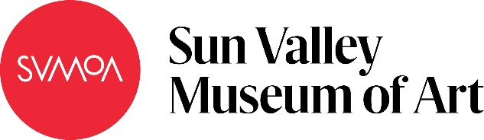

Mega Molecules
Subject: Science
Grade Level: 6
Lesson Plan: Seven 50-minute classes

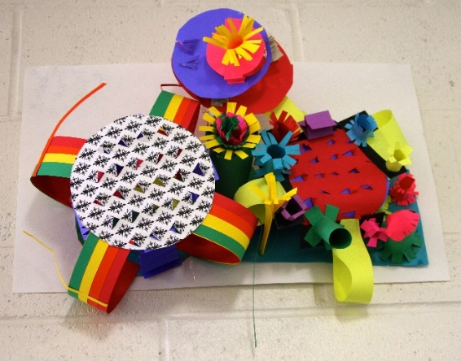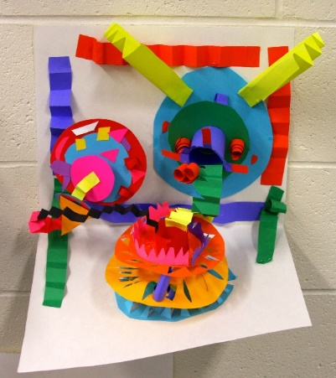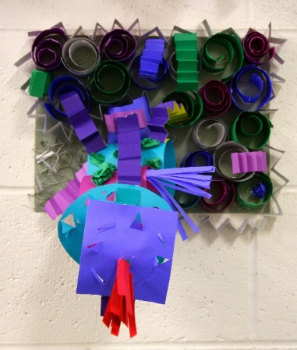

Small groups of students choose a molecule. Then, individually, students create the elements of the molecule compound using paper manipulation techniques including kirigami and quilling. The individual elements are then combined into one sculpture to create the compound.

Objectives:
- Students will create an element
- Students will work together to create a molecule
- Students will present their work to the class
- Students will write an artist’s statement

Basic Outline of the Lesson:
- Introduce of the project
- Introduce the materials and let students experiment with them
- Students create sculptures
- In small groups, students combine sculptures to create molecules
- Students present their molecules
- Students write their artist’s statements

Art Supplies:
- Miscellaneous colored paper
- Miscellaneous colored card stock
- Pencils / erasers
- Rulers
- Cutting boards
- X-ACTO knives / blades
- Scissors
- Glue sticks
- Hot glue guns / glue gun sticks
- Tape
- Drawing paper
- Tag board for presenting molecules

Other Resources:
- Examples of paper sculptures and how to manipulate paper (kirigami and quilling)
- Molecule list
- Slide show to introduce project and related artwork (see outline at the end of the lesson plan)

Idaho State Learning Standards:
- Arts and Humanities: Anchor Standard 4: Convey meaning through the presentation/performance/production of an original work or unique interpretation of a work.
  - Objective PR1.1 Combine knowledge and understanding from two or more disciplines to present/perform their original or interpreted works for an audience
  - Objective PR1.2 Convey meaning through their presentation/performance

- Physical Sciences: PS1-MS Matter and Its Interactions
  - PS1-MS-1. Develop models to describe the atomic composition of simple molecules and extended structures.
    - Further Explanation: Emphasis is on developing models of molecules that vary in complexity. Examples of simple molecules could include ammonia and methanol. Examples of extended structures could include sodium chloride or diamonds. Examples of molecular-level models could include drawings, 3D ball and stick structures, or computer representations showing different molecules with different types of atoms.
  - PS1.A: Structure and Properties of Matter
    - Substances are made from different types of atoms, which combine with one another in various ways. Atoms form molecules that range in size from two to thousands of atoms. (PS1-MS-1)

Academic Language:
- Subject area language: atom, compound, molecule
- Art language: paper manipulation, quilling, kirigami

Student Use of Vocabulary:
Students will use the words when creating their projects, presenting their molecules and writing their artist statements

Student Grouping:
Students will work in small groups and individually

Instruction:
Day 1 – Introduction
- Introduce the project with a slide show (see additional resources)
- Questions to ask during the slide show include:
  - What do you see?
  - How do you think the artists created this art?
  - Why do you think the artists created this art?
  - How do you think these artists used science in their art?
- Explain the creative process for the project
  - Demonstrate paper manipulation techniques
  - Kirigami (decorative paper cutting and folding)
  - Quilling (rolling and gluing paper)
  - If time remains, students can experiment with paper techniques
Day 2 – Artmaking
- Divide students into small groups based on compound /molecules and the number of elements in each
- Some students can work alone if the atom has only one element
- Students should begin designing and sketching their sculpture
Day 3 – Artmaking
- Discuss/demonstrate how to safely use an X-ACTO knife and glue gun
- Students should start working on creating their sculptures, using the paper manipulation techniques
- Students should refer to their sketches when creating their elements
Day 4 – Artmaking
- Students should work on creating their sculptures
- Encourage the students to finish their sculptures
Day 5 – Artmaking
- Students should finish their elements
- Students should work in their groups to arrange and connect their sculptures on the poster board
- Students should use paper manipulation techniques to connect their sculptures
- Remind students to put their names on the back of the poster board
Day 6 – Presentation
- Student groups should prepare to present their sculptures to the class
- Students should present their sculptures to the class
- At the end of the class, the teacher can collect student work to display in the hall
Day 7 – Artist Statements
Students should write their individual artists statements

Additional Resources:
Instructional video at svmoa.org

https://charlesclary.com/
http://www.crystalwagner.com/
http://www.jenstark.com/
http://www.kumiyamashita.com/
http://www.petercallesen.com/home/
http://roganbrown.com/home.html
http://hubpages.com/art/paper-cutting-art-techniques-how-to-cut-intricate-patterns-projects-for-beginners

Slide Show Outline:
Slide Examples:
- Examples of science and art
- Examples of paper art
- Examples of paper manipulation techniques
  - Cutting / kirigami
  - Folding / shadows
  - Quilling
  - Stacking / layering
- Project Goals:
  - Choose a compound and determine what elements / molecules make up the compound you have chosen
  - Make a plan of attack with your group
  - Sketch your composition
  - Build your composition
  - Write an artist statement
  - Display
- Art used in the original slide show:
  - “Specimen Case No. 12” by Roxy Paine
  - “Neuron” by Roxy Paine
  - “Daily Petri Dish” by Klari Reis
  - Rogan Brown
  - Chinese Paper Cutting
  - Japanese Kirigami
  - French Renaissance religious quilling and paper filigree (used to decorate books)
  - Swiss and German folded and flat cut
  - French silhouettes
  - Mexican papel picado – fine tissue paper cut with chisels
  - Matisse drawing with scissors
  - Jean or Hans Arp (Dada) – composition is left to chance
  - Sachin Tekade paper cutting
  - Peter Callesen
  - Kumi Yamashita
  - Yulia Brodskaya
  - “Daydream” by Lauri Brown
  - Jen Stark
  - Crystal Wagner
  - Lauren Clay

Funding for this lesson plan was made possible in part by the Institute of Museum and Library Services [MA-10-19-0563-19].
Additional funding provided by Wendy and Alan Pesky.
